Project Synopsis
On



Movie Flix

Table of Contents

S. No. | Topic Name | Page No.
1 | Title of the project | 1
2 | Introduction and Objectives of the Project | 3-5
3 | Module Description | 6-8
4 | Analysis (DFDs, ER Diagram) | 9-12
5 | Data Structure | 13-17
6 | Software & Hardware Tools | 18-19
7 | Future Scope | 20

Introduction of Project

In this case, we will be designing a simple online movie rental. The site will provide a soothing experience for customers. The system will allow more than one category of movies of different banners. Customer can send pick-up request to us for the movie that he wants to borrow for few numbers of days. Our one of the staff member delivered that movie within a day at the customer place and picked up the movie. Rental charges of each movie are same for all our customer but number of movies a user can borrow at a time is depends on its membership plan.

Project Objective

Objective
This project has been developed keeping in view the security features that need to be implemented in the networks following the fulfillment of these objectives:
- Provide a user friendly interface to the user such that he can borrow movie for few days & he can also create his queue.
- User can make a request of the required movie from his queue for delivery.

Assumptions
The currency followed is Rs as the site provides for only Indian customer base.
- There are different segments, categories, brands where a brand can fall under more than one category.
- The shipment of the goods is not covered under the scope of the case
- Complains by the customers are not handled by the case study.
- Customers have to be validated before the payment can be confirmed.
Project Overview
A customer visits the online movie rental. A customer may select any movie that he wants to borrow or just visit the page and logout. The customer can select a genre, then a language, to get the different movies as he desired. And there are various other ways that a user can search for his desired movie.
The customer can select the movie for putting them in his queue. The process can be repeated for more movies. Once the customer finishes selecting the movie/s the queue can be viewed, if the customer wants to edit the final queue it can be done here. Customer can update or delete movies for his queue anytime.
For final delivery of selected borrowed movie, the customer has to login the portal, if the customer is visiting for the 1st time he must register with the site, else the customer must use the login page to proceed.
Finally customer has to request for the desired movie from the queue for delivery. That movie is delivered at their place within a day also picked up from there after few days or requested by the customer to pick this movie or pick and deliver next movie.

Module Description

Modules:

- Registration
- Search
- Report
- Security
- Admin
- Staff
- User
Brief Description:

Registration:
Through this module a person can register with the website. A registered user can add movies to the queue and see rental history and update his profile. A user can keep any int of movies as he wishes, but only the first movie is delivered to him in the next delivery cycle. A person needs to choose a plan to be registered and join with us. Valid email id is required as user id.

Search: This module is the most important module of this project. Visitor & User can search movie by various ways. These ways are explained as below
- By Combination of Language & Genre
- By Alphabet
- By Collection
  - By year like movies of 80's, 90's or 2000
  - By Award Winning movies
(NOTE: These above two options are available for both Indian and International Category)
- By Name of
  - Actor
  - Actress
  - Producer
  - Director
Report:
This module works for us whenever admin or user wants to take a report of any type like…
- Admin can take a report of all payment made by any user during registration
- Admin can also take report of all customer details
- Rental history that shows disc to be delivered as well as or disc to be picked up.

Security: Security is one of the most important aspects of any project. Following security measures have been taken:

Login:

This is a sub module of Security Module. This module authenticates and authorizes the user. If the user has forgotten the password then Once visitor is registered with us, now can borrow movie from us but before that he has to choose or make a queue that he/she want to watch in future. And also reserve his/her movie for delivery at his/her place. Session is created after successful login

Logout:
This module is again sub module of Security. Session expires after successful logout

Captcha
A captcha is a set of letters and or numbers presented under the form of a small picture. The trick is that the captcha containing letters and or numbers is distorted badly. Basically, the captcha is designed to be able to make a distinction between human started submission of web-forms and automated software queries, and help separate them accordingly.

Auto Logout

If no requests come from the same user for the next 30 minutes then user is logged out automatically.

Admin: Admin is the only authorized person who governs this site. He can perform following activities:
- Add Movie/ Membership Plan / Staff
- Update Profile/Password/Movie Details/Movie Image/Int Of Discs
- Delete Movie
- Reports
  - Payment Details
  - Delivery Details
  - Discs Details
  - Posted Feedbacks

User: User can search any movie from his/her choice and make a queue according with that. Now, he/she can reserve any movie or delete any movie from the queue. If he/she reserve any movie its mean that he/she want that movie to be delivered to him.
- My Profile
- Add Movie To Queue/ Deliver or Reserve List
- Update Profile / Password
- View
  - My Queue
  - Rental History
  - Popular Movies
  - Locate Stores
  - New Membership Plans
- Post Feedback

Staff: our Staff person is that, who delivered and take back movie to the respective user on time.
- My Profile
- Update Profile / Password
- Check New Movie Delivery Requests
- Reports New Delivery Requests

Analysis

Data Flow Diagram

Data Flow Diagram

The Data flow Diagram shows the flow of data. It is generally made of symbols given below: -

- A rectangle shows the Source/Sink: -

- A Circle shows the Process: -

- An open Ended Rectangle shows the data store : -

- An arrow shows the data flow :-

The DFD can be up to several levels. The 0 level DFD states the flow of data in the system as seen from the outward in each module.

The first level DFD show more detail, about the single process of the 0 level DFD

The second level DFD can show even more details and so on.

Context Level Diagram

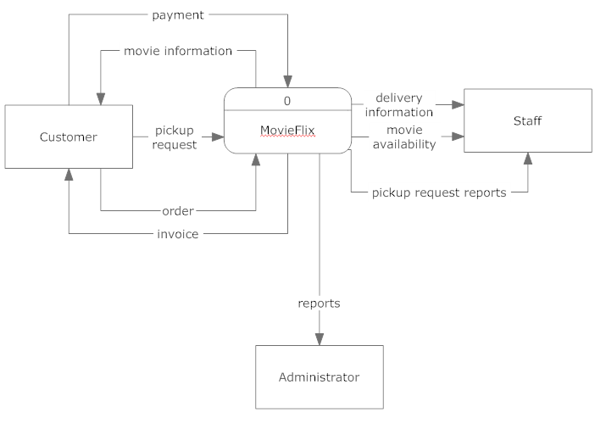
Level – 0 Diagram

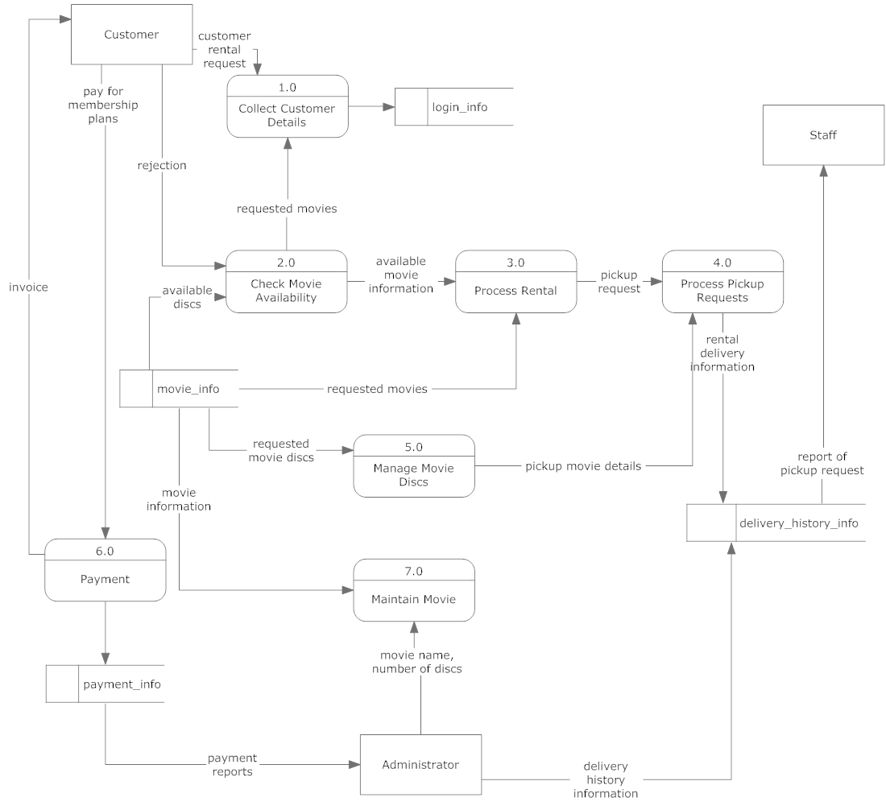
ER Diagram
Address
Lname
Fname
Role
User_id
plan_id
user_info
sex
Mobile
DOB
login_info
user_id
sec_answer
sec_ques
password
movie_info
movie_id
Movie_name
Released_date
Censor_certified
Language
Producer
Director
Actor
Actress
Image_name
Nation
genre_info
genre_id
genre_name
movie_genre_info
movie_genre_id
movie_id
genre_id
award_info
award_id
movie_id
award_name
award_year
queue_info
movie_id
cart_id
user_id
queue_id
cart_info
user_id
totalcost
Purchased_date
Purchased_time
payment_id
payment_info
cart_id
payment_type
amount
cart_id
cartitem_info
cartitem_id
quantity
totalcost
movie_id
comment_id
comment_info
Comment_type
comment_by
Person_email
Comment_on
Remarks
buys
M
M
added to
made of
1
N
done for
1
1
does
1
N
can post
can add
1
N
have
1
1
M
M
can have
have
1
1
have
1
1
have
1
1
1
N
1
N
plan_info
plan_id
Plan_name
no_of_discs_at_a_
time
refundable_amt
Subscription_amt
plan_duration
plan_type
has
N
1
award_winning
_status
Data Structure

- Table: plan_info

To maintain the records of different plans

Column Name | Data Type | Size | Constraint | Description
plan_id | Int | 5 | Primary key | Plan id of the plan
Plan_name | Varchar | 30 | Not null | Name of the plan
plan_type | Varchar | 10 | Not null | Type of plan
plan_duration | Varchar | 12 |  | Duration of the plan
Subscription_amt | Int | 5 | Not null | Amount to subscribe the plan
refundable_amt | Int | 5 | Not null | Refundable amount
no_of_discs_at_a_time | Int | 10 | Not null | No of discs provided to the user

- Table: user_info

To maintain the records of different user either he/she is admin or user

Column Name | Data Type | Size | Constraint | Description
User_id | Varchar | 20 | Primary Key | User ID of user
plan_id | Int | 5 | Foreign key
Role | Varchar | 10 | Not null | Role of user
Fname | Varchar | 20 | Not null | First name of user
Lname | Varchar | 20 |  | Last name of user
Sex | Varchar | 6 | Male, Female | Gender of the user
Address | Varchar | 50 |  | Address of user
Mobile | Int | 10 | Not null | Mobile int of user
DOB | date |  | Not null | Date of birth of user

- Table: login_info

To maintain the username and the related password of different admin/user/staff

Column Name | Data Type | Size | Constraint | Description
User_id | Varchar | 20 | Foreign key | Valid email
Password | Varchar | 20 | Not null | Password of user for login
Sec_ques | Varchar | 20 | Not null | Security question of user for regaining the password details
Sec_answer | Varchar | 50 | Not null | Security answer of user for regaining the password details

- Table: movie_info

To maintain the username and the related password of different admin/user

Column Name | Data Type | Size | Constraint | Description
Movie_id | Int | 5 | Primary key | Movie id of the movie
Movie_name | Varchar | 20 | Not null | Name of the movie
Released_date | Date |  |  | Released date of the movie
Director | Varchar | 20 | Not null | Director of the movie
Actor | Varchar | 20 | Not null | Male Actor of the movie
Actress | Varchar | 20 | Not null | Female Actor of the movie
Producer | Varchar | 20 | Not null | Producer of the movie
Language | Varchar | 10 | Not null | Language of the movie
Censor_certified | Varchar | 5 | A, U/A, U | Censor certificate of the movie
Image_name | Varchar | 30 | Not null | Name of the image
award_winning_status | Int | 1 | 1 or 0 | This shows that movie is award winning or not. By default movie is not award winning
Nation | Varchar | 13 | Indian or International | Nationality of the movie
No_of_discs | Int | 5 | Not null | No of discs of a particular movie

- Table: genre_info

To maintain the records of different genre

Column Name | Data Type | Size | Constraint | Description
genre_id | Int | 5 | Primary Key | Genre ID
genre_name | Varchar | 15 | Action, Comedy, Drama, Horror, Family, Spiritual, Historical, Romance, etc | Name of the genre

- Table: movie_genre_info

To maintain the records of each movie with its genre

Column Name | Data Type | Size | Constraint | Description
movie_ genre _id | int | 5 | Primary key | Combine ID of both Movie ID & Genre ID
movie_id | Int | 5 | Foreign key | Movie ID
genre _id | Int | 5 | Foreign Key | Genre ID

- Table: award _info

To maintain the records of awards of each movie

Column Name | Data Type | Size | Constraint | Description
award_id | Int | 5 | Primary Key | Category ID
Movie_id | Int | 5 | Foreign key | Movie ID
award_name | Varchar | 30 |  | Name of the award
award_year | Date |  |  | On what date award is given to the movie
- Table: queue _info

To maintain the records of movies added by the user in queue

Column Name | Data Type | Size | Constraint | Description
queue_id | Int | 10 | Primary key | Queue ID
movie_id | Int | 10 | Foreign key | Movie ID
user_id | Varchar | 20 | Foreign key | User ID to whom movie is allotted
status | Varchar | 20 |  | Status of the movie that is either awaiting, delivered or reserve
Reserved_date | date |  | Not null | On what date movie is reserved by the user

- Table: delivery_history _info
To maintain the records of movies that was delivered to the user

Column_name | Data Type | Size | Constraint | Description
delivery_history _id | Int | 5 | Primary Key | Delivery ID
Movie_id | Int | 5 | Foreign key | Movie ID of the movie_info table
User_id | Varchar | 20 | Foreign key | User ID of the user_info table
delivered_on | Date |  | Not null | Delivery date of the movie
Returned _on | Date |  | Not null | Returned date of the movie
Delivered_by | Varchar | 5 | Foreign key | User ID of a specific staff from the user_info table who delivered this movie to the user

- Table: request _info
To maintain the records of movies that are requested by the user from his/her queue
Column Name | Data Type | Size | Constraint | Description
request_id | Int | 5 | Primary Key | Request ID
Queue_id | Int | 5 | Foreign Key | Queue ID of the queue_info table

- Table: payment _info
To maintain the records of payment of each payment when user chooses his/her membership plan

Column Name | Data Type | Size | Constraint | Description
Payment_id | Int | 5 | Primary Key | Payment ID
User_id | Varchar | 20 | Foreign key | User ID of the user_info table to check who pay this payment to us
Payment_type | Varchar | 10 | Credit Card | Type of payment user want to pay
Amount | int | 5 | Not null | Amount of payment that was paid by user
Payment_date | Date | 7 | Not null | Payment date
Payment_time | Varchar | 5 | Not null | Payment time

- Table: comment _info
To maintain the records of comments posted by the user

Column Name | Data Type | Size | Constraint | Description
Comment_id | Int | 5 | Primary Key
Comment_type | Varchar | 10 | Suggestion, Complaint, Query | Types of comments the user can post
Comment_on | Varchar | 10 | Mall Services, Stores, Dining, Staff, Others | Thing on which user want to comment
comment_by | Varchar | 10 |  | Name of the person who post the comment
Person_email | Varchar | 30 | Not null | Email address of the person
Remarks | Varchar | 100 | Not null | The comment that he/she want to post

Software & Hardware Tools

Development Environment:
- Operating System: Linux Red Hat, Windows XP SP2 or above
The system will be built on windows compatible environment. The application will be web based developed using Java technology.
- Integrated Development Environment(IDE): Eclipse Helios
Eclipse is a multi-language software development environment comprising an integrated development environment (IDE) and an extensible plug-in system.
- Web Server: Tomcat 7.0
Apache Tomcat is an open source software implementation of the Java Servlet and Java Server Pages technologies. Apache Tomcat is an open source software implementation of the Java Servlet and Java Server Pages technologies.
- Data Base: My SQL 5.0
MySQL is a relational database management system (RDBMS) that runs as a server providing multi-user access to a int of databases.
- Client Browsers:
Support all browsers
- Dream Weaver CS5
The system will be developed with Java Technologies using J2SE (JDK and JRE). Dream Weaver CS5 as HTML editor

Hardware & Software Requirements:
Hardware requirement

Main Processor Pentium IV or above
Hard-disk Capacity 8 G.B or more
RAM 256 MB or more

Software Requirement

Operating System Linux Red Hat, Window XP SP2 or other
Backend tool My SQL 5.0

Future Scope

- Providing the SMS alerts of latest movies to the user.
- Providing Email account facility to users so they can feel the independence of mail account at the same site.
- Provide email facility to the user of all the upcoming movies & their details for rental.

